 | EMBASSY OF INDIA  KUWAIT

Press Release

Indian Embassy organized a “Made in India Exhibition” in Holiday Inn Hotel, Salmiya on Saturday, 18th February 2017 from 10:30 am - 8:00 pm. Ambassador of India to Kuwait H.E. Mr. Sunil Jain inaugurated the Exhibition. The main aim of the Exhibition was to promote Made in India products, especially Indian Automobiles and Home appliances in Kuwait.

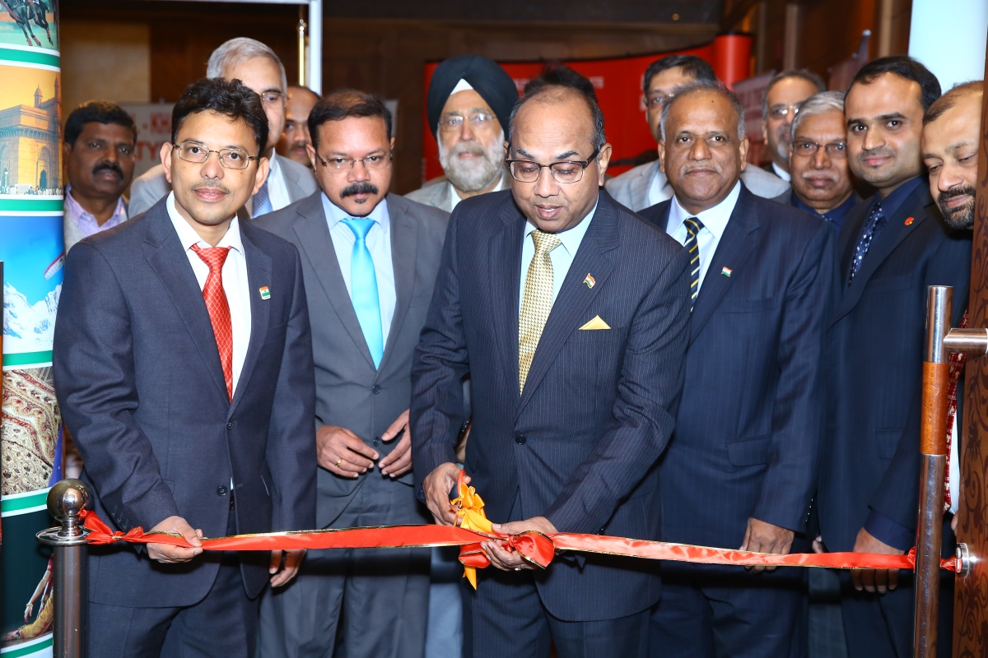

2. The “Made in India Exhibition” provided Kuwaitis, Indians and other foreign nationals a chance to see the display of a wide variety of Indian automobile and home appliances under one roof in Kuwait. A wide variety of Indian products ranging from tyres, motorbikes, trucks, buses, security solutions, batteries, air compressors, fans, mixies, tableware, cookware, televisions, refrigerators, etc., were displayed in the Exhibition.

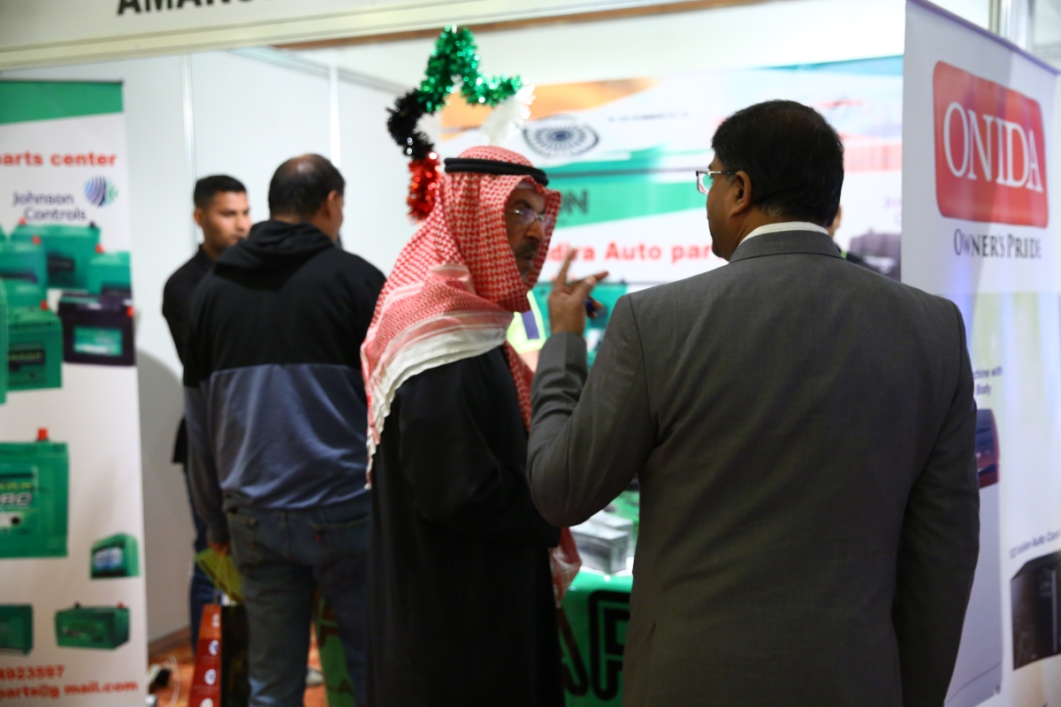

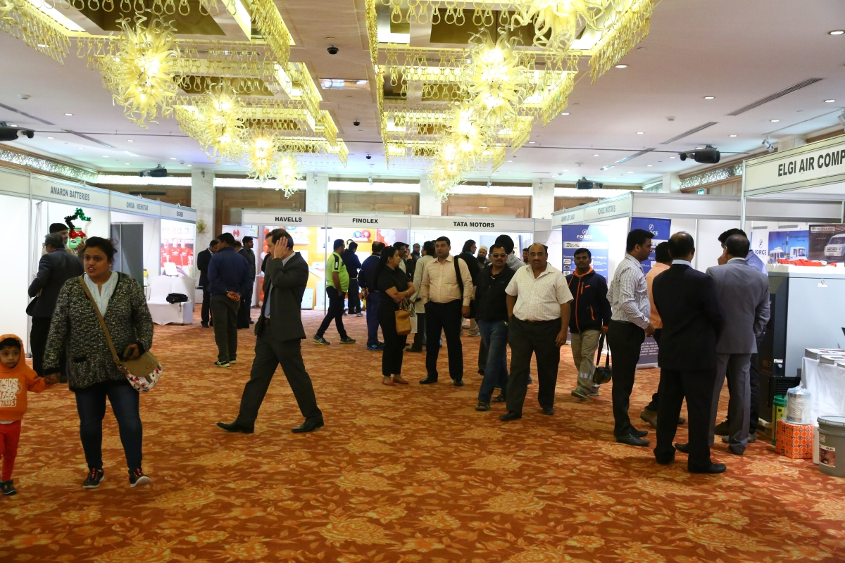

3. Companies dealing in 30 Indian reputed brands viz., Ceat Tyres, TVS Tyres, Index Batteries, Apollo Tyres, Royal Enfield Bikes, Eicher Trucks, TATA Buses and Trucks, Ashok Leyland Buses, Godrej Security Solutions, Godrej Interio, Amaron Batteries, Laopala Tableware, Havells, Finolex, Onida TVs, Kenstar Kitchen appliances and Air Coolers, Videocon TVs and refrigerators, VIP Luggages, Force Mini Buses, ELGI Air Compressors, MRF Tyres, JK Tyres, Servo Oil, Mahindra pick-ups, Suzuki (Maruti Cars), Kent Water Purifiers, Balkrishna Tyres, Butterfly mixies, Pigeon mixies and cooking utensils, etc., participated in the Exhibition.

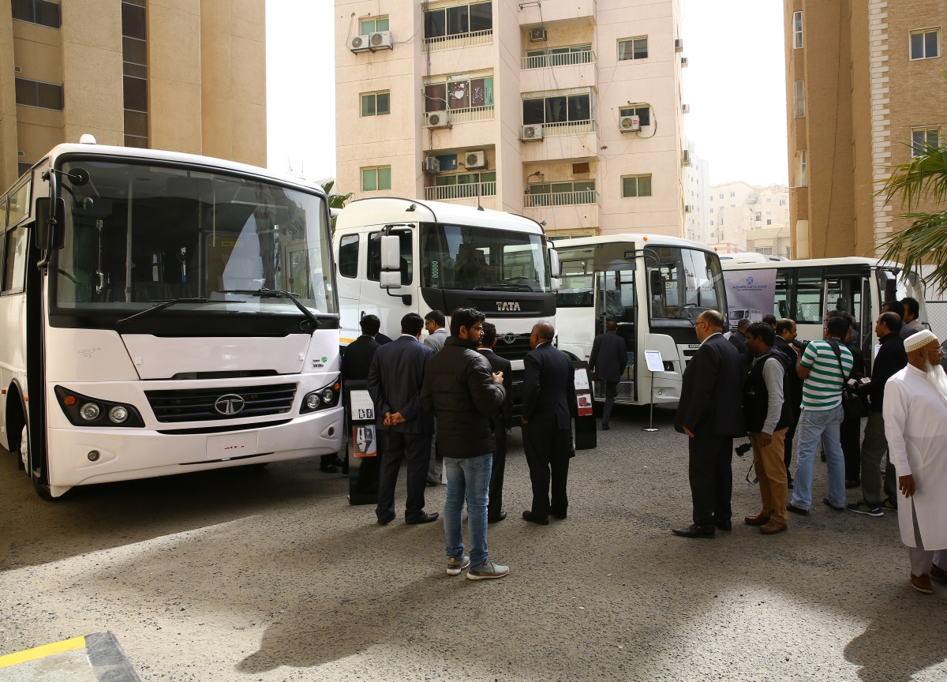

4. Display of Indian automobiles was a special attraction at the Exhibition. The Exhibition attracted large number of visitors throughout the day.

February 20, 2017

******

