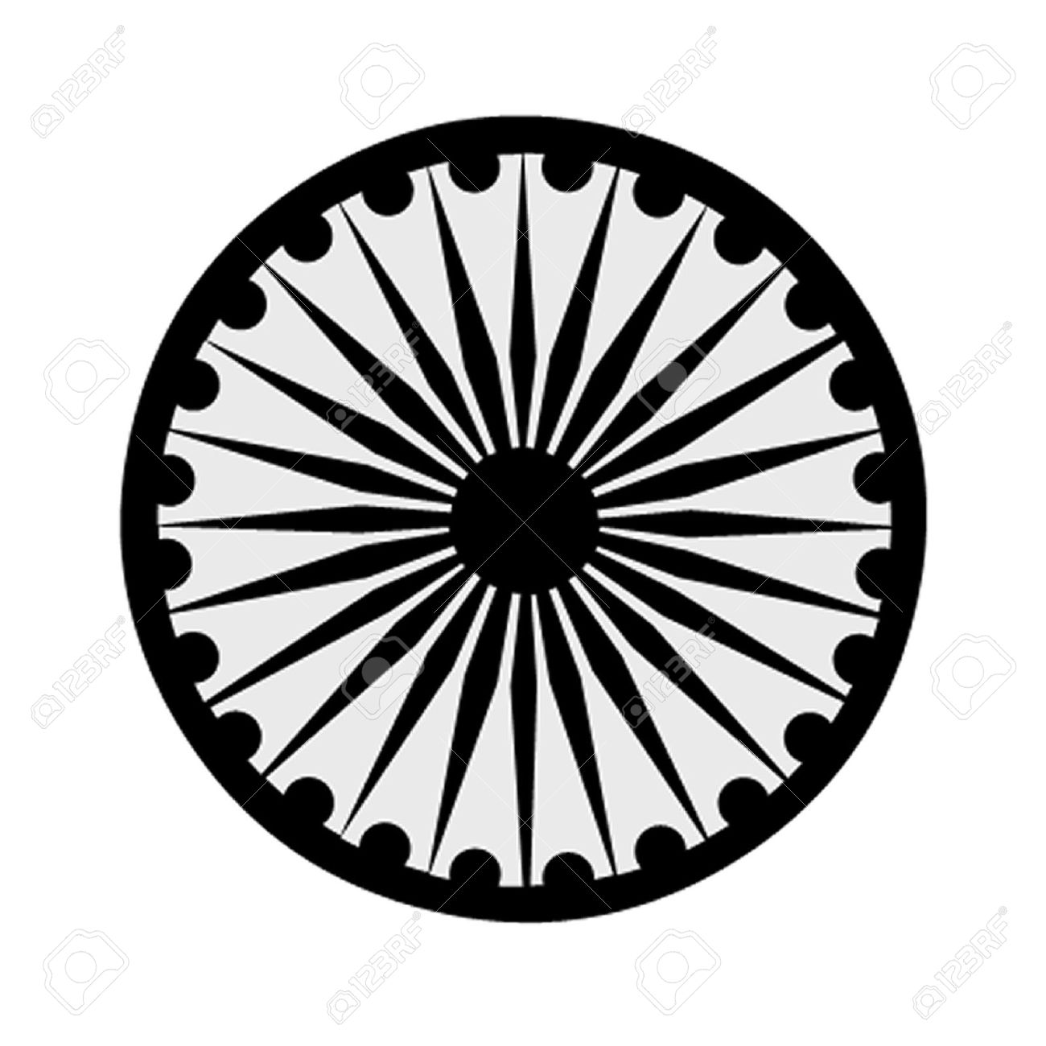 | HIGH COMMISSION OF INDIA, BRUNEI DARUSSALAM  P.O. BOX 439, LAPANGAN TERBANG LAMA  BANDAR SERI BEGAWAN BB 2339685  Telephone: 2339947 / 2339685  Fax: 2339783  E-mail: hoc.brunei@mea.gov.in  Website: www.hcindiabrunei.gov.in

PRESS RELEASE

Subject: Hindi Pakhwada – 14-29 September 2023; India House.

The “Hindi Pakhwada” was celebrated by High Commission from 14-29 September 2023.

2. The event highlighted Hindi usage, raise its awareness among the diaspora and particularly youth, students and teaching community.

3. Hindi Diwas was organised at “India-House” on 29th September 2023, that was attended by representatives from academic, education, media, communications and the overseas community. Members of Indian Associations were also present.

4. High Commissioner, on this occasion, read Hon’ble Home Minister’s message. In his remarks, High Commissioner highlighted Hindi’s growing relevance and encouraged participants to learn the language, which is spoken by well over 600 million people globally, and to use it in daily life. Other speakers highlighted similarities between Hindi and Malay languages; use of Hindi in Brunei and as to its further expansion. Young students from Brunei Reading and Literacy Association (ReLa) performed short-skits to promote Hindi Language. Madam Hajah Mariam Haji Ladi, Principal, Yayasan Sultan Haji Hassanal Bolkiah School, spoke on the significance of language.

5. High Commissioner gave prizes to the participating children to encourage use of Hindi in daily life. Indian meals and savories were also served on the occasion.

****

Bandar Seri Begawan High Commission of India
3 October, 2023 Brunei Darussalam

