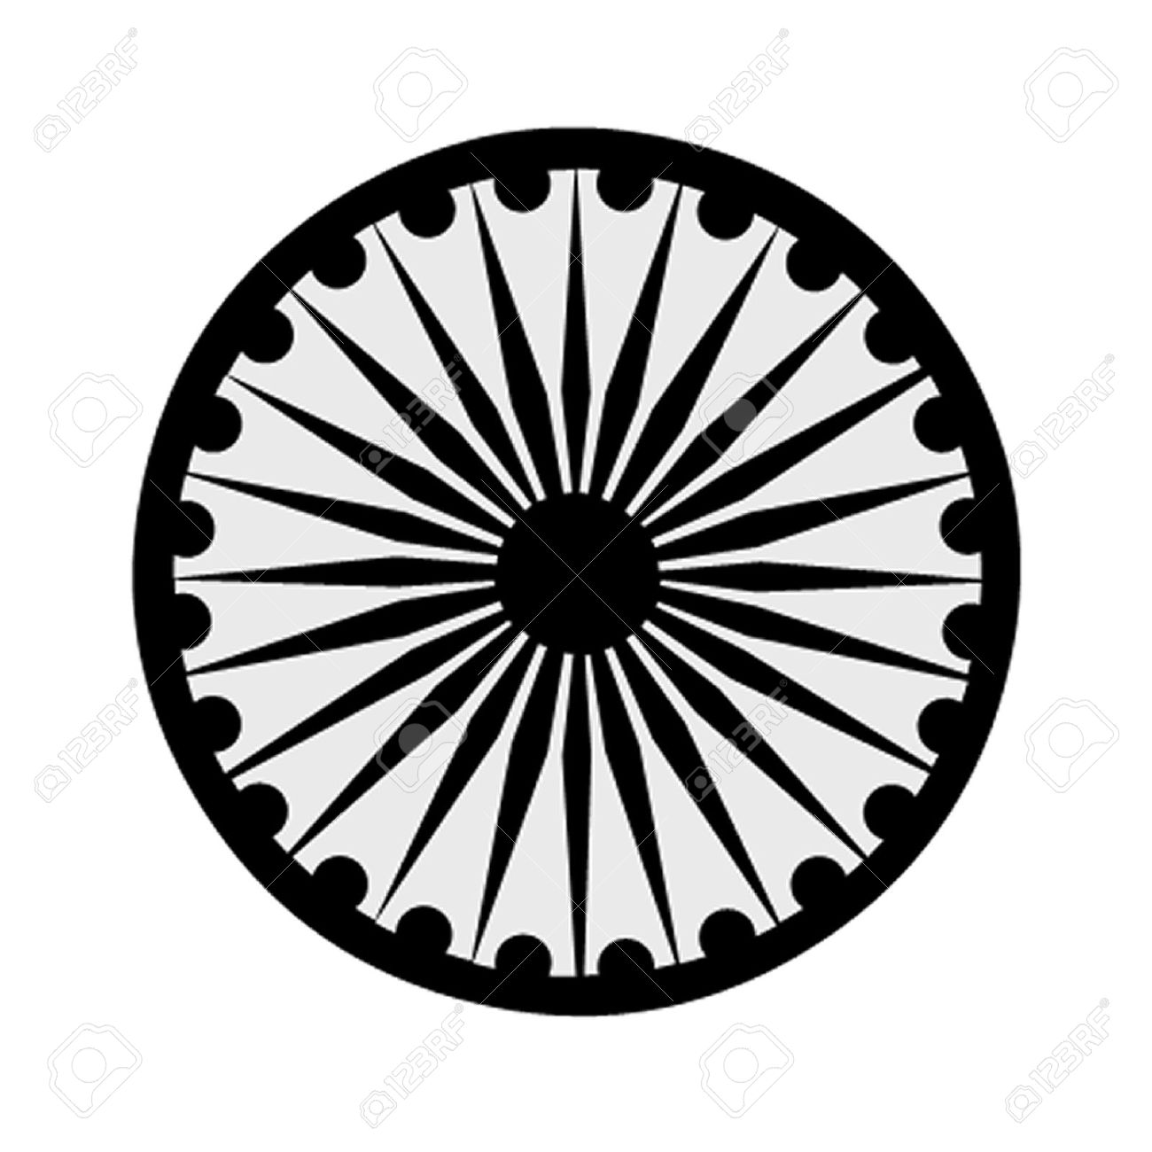 | HIGH COMMISSION OF INDIA, BRUNEI DARUSSALAM  P.O. BOX 439, LAPANGAN TERBANG LAMA  BANDAR SERI BEGAWAN BB 2339685  Telephone: 2339947 / 2339685  Fax: 2339783  E-mail: hoc.brunei@mea.gov.in  Website: www.hcindiabrunei.gov.in

PRESS RELEASE

National Sports Day Celebration – 29 August 2023

High Commission celebrated the National Sports Day on 29 August 2023.
2. In the run-up to the event, Mission promoted and publicized the event themed “Sports as an enabler for an inclusive and fit society”, on its social media handles.
3. On 29 August, Mission officials participated in sports activities organised at the Chancery premises, namely, badminton, cycling, brisk walk. Head of Chancery in his remarks, highlighted the importance of sports in our daily lives and how we can live a healthier life; manage stress and chronic health challenges through simple life-style changes and becoming physically more active. He also administered the ‘Fit India Pledge’ and encouraged Mission officials to include physical activities in their everyday lives and spread awareness about the health benefits of engaging in regular physical exercise.

****

Bandar Seri Begawan High Commission of India
30 August, 2023 Brunei Darussalam

