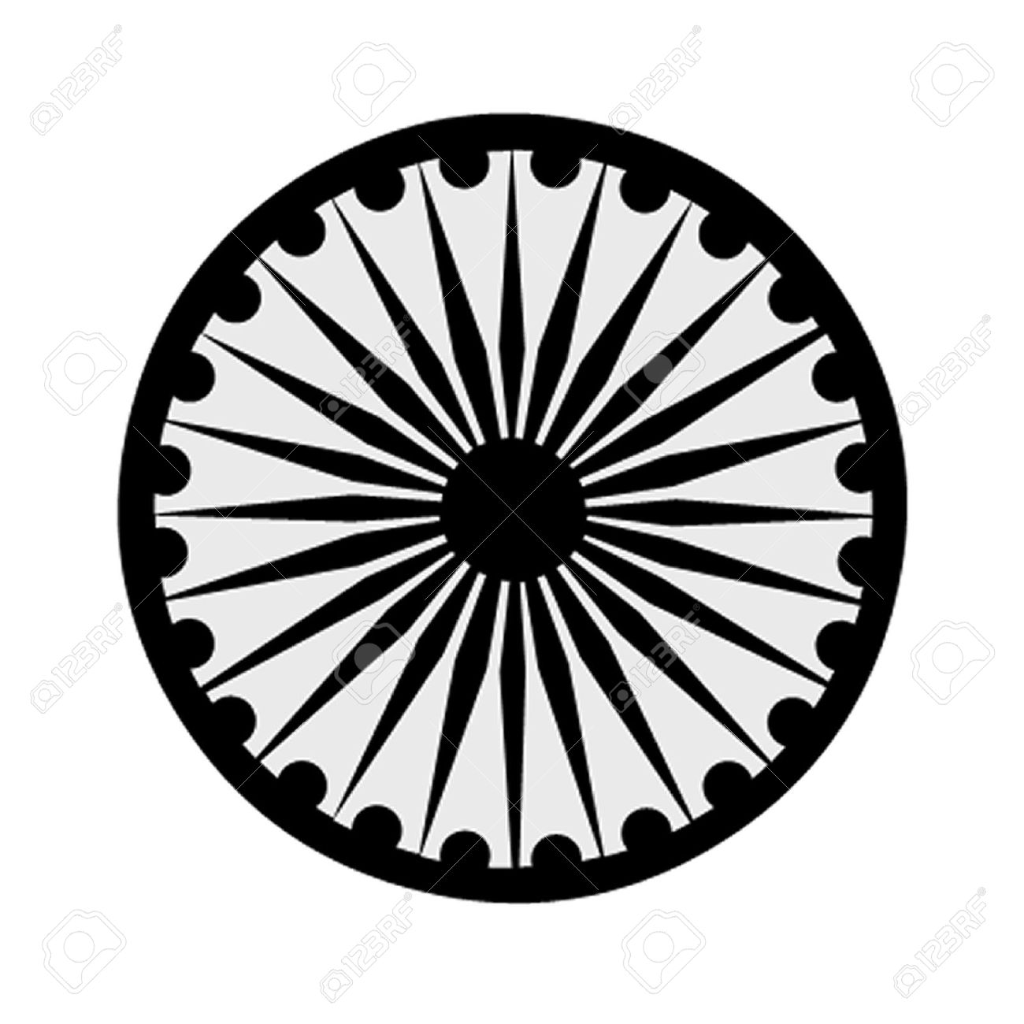 | HIGH COMMISSION OF INDIA, BRUNEI DARUSSALAM  P.O. BOX 439, LAPANGAN TERBANG LAMA  BANDAR SERI BEGAWAN BB 2339685  Telephone: 2339947 / 2339685  Fax: 2339783  E-mail: hoc.brunei@mea.gov.in  Website: www.hcindiabrunei.gov.in

PRESS RELEASE

Commemoration of 59th Indian Technical and Economic Cooperation Day (ITEC Day-2023), Friday, 17 November 2023.

The fifty-ninth ITEC Day-2023 was celebrated on 17 November, 2023, at the India House, High Commission of India, Brunei Darussalam.

2. Nearly sixty guests, ITEC alumni, representatives from academia, Government, local chambers of trade, students, prominent members of media and diaspora were in attendance.

3. His Excellency, Ambassador Alok A. Dimri, High Commissioner of India, in his opening remarks, highlighted ITEC as an important platform for technical-assistance and capacity-building that India offers to its ITEC partner countries, including Brunei. That India has shared its developmental experience and expertise with well over hundred and sixty countries across the Global South in keeping with the tenets of ‘Vasudhaiva Kutumbakam’ - that “the entire World is one Family one Home”. Sixty-six Bruneian nationals thus far have availed of ITEC Fellowships.

4. Details of upcoming ITEC Fellowships are regularly shared with the Bruneian counterparts. Government of India accords full-hospitality to the ITEC participants. About three hundred ITEC courses in myraid domains are offered annually to nearly fifteen-thousand personnel from partner countries.

5. The High Commissioner noted customized ITEC programmes, in keeping with Brunei’s national priorities in MSMEs, IT, cyber, Space, defence, audit, banking etc. High Commissioner briefly touched upon India’s New Education Policy, and encouraged Bruneians to take advantage of setting up of overseas campuses of IITs & AIIMS.

6. Brunei participants shared their ITEC experiences and how it has helped in furthering their career.

7. The event was live-streamed on social-media. The event concluded with a dinner/reception over Indian cuisine and delicacies.

*****
Bandar Seri Begawan High Commission of India
17 November, 2023 Brunei Darussalam

