Embassy of India
Bangkok
*****
Fact Sheet: Thailand
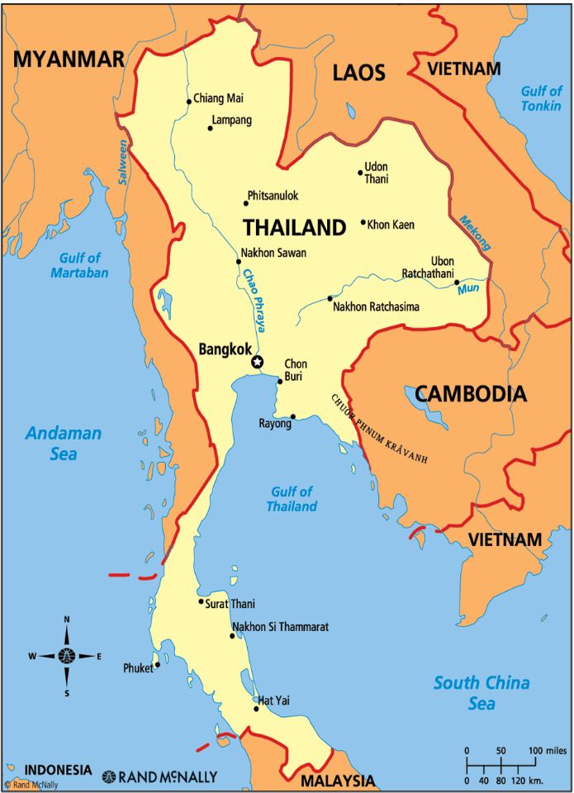
GENERAL
Official Name | Kingdom of Thailand
Capital | Bangkok
Area | 513,120 sq km [World's 50th largest country in terms of total area (about 1/6th of India)]
Weather | Thailand has tropical savanna climate, influenced by monsoon winds. The weather of Thailand is mostly hot throughout the year with the temperature ranging between 30-34°C. The year is divided into three seasons (i) Summer season or pre-monsoon season (mid February to mid May) (ii) Rainy season or the southwest monsoon season (mid May to mid October) and (iii) Winter season or the northeast monsoon season (mid October to mid February).
Population | 66.09 Million (2022)  [As announced by Central Registration Bureau of Thailand, the population of Thailand stood at 66,090,475 as of 31 December 2022.]
Forest Cover (% of total area) | 31.9%
Tourists Arrivals(Yearly) | 39.79 million (2019)  6.7 million (2020)  472,869 (2021)  11.04 million (2022)
Age Profile | 0-14 years 16.49%  15-24 years 12.73%  25-54 years 45.10%  55-64 years 13.12%  65 years and above 12.57%
Life Expectancy | 77.5 years  Male: 74.39 years  Female: 80.6 years
Languages (with % age of speakers, if available) | Thai
Ethnic Groups | Thais: 75%  Thai Chinese: 14%  Malay Muslims: 4%  Khmers: 3%  Highland indigenous Groups: 1.2%
Main Religions  (with %, if available) | Buddhism: 95%  Islam: 4%  Others (Hinduism, Christianity etc.): 1%
Internet Penetration | 46 million (69.5 % of total population) [2021]
Mobile Phones | 90.66 million [2021]
Urbanization | More than 50% of total population lives in urban areas
ECONOMIC
Currency | Baht
Exchange rate with US $ & Rs. | US$ 1 = around Baht 34.52] [Baht 1= around INR 2.35], as on 24 February 2023.
GDP | Baht 17,367.31 billion (Approx. US$ 495 billion)
GDP Growth Rate | 2.4% (2019)  -6.20% (2020)  1.6% (2021)  2.6% (2022)
Major Sectors (% of GDP)  As of 2021 | Agriculture: 8.54%  Industrial: 32.01%  Service: 59.39%
GDP Per Capita | US$ 7,089.7 (2022)
Total Trade | US$ 590.26 billion (2022)
Exports | US$ 287.07 billion (2022)
Imports | US$ 303.19 billion (2022)
Balance of Trade | Trade deficit US$ 16.12 billion (2022)
Forex | US$ 216.63 billion (2022) (Source: Bank of Thailand)
Major Trading Partners  (Source: Ministry of Commerce of Thailand) | In terms of total trade (2022) [amount in US$ billion]  (i) China 105.40 (ii) U.S. 65.55 (iii) Japan 59.25 (iv) Malaysia 27.19 (v) Vietnam 21.19 (vi) United Arab Emirates 20.82 (vii) Indonesia 20.03 (viii) Singapore 18.53 (ix) Australia 18.39  India stands at 10th position with total trade of 17.70 billion US$  In terms of Export (2022) [amount in US$ billion]  (i) US 47.53 (ii) China 34.39 (iii) Japan 24.67 (iv) Vietnam 13.24 (v) Malaysia 12.69 (vi) Australia 11.15  India stands at 7th position with export from Thailand 10.52 billion US$  In terms of Import (2022) [amount in US$ billion]  (i) China 71.01 (ii) Japan 34.58 (iii) U.S. 18.02 (iv) UAE 17.40 (v) Malaysia 14.51 (vi) Taiwan 11.85 (vii) South Korea 10.14 (viii) Indonesia 9.71 (ix) Singapore 8.26 (x) Vietnam 7.96 (xi) Australia 7.23  India stands at 12th position with import from India 7.18 billion US$
POLITICAL
Political Structure | Thailand has a Constitutional Monarchy. The current Head of State is King Rama X and the Head of the Government is Prime Minister General Prayut Chan-o-cha. Parliament of Thailand has two houses, (i) House of Representatives (Lower House) and (ii) Senate (Upper House). House of Representatives has 500 members of which 350 members are constituency MPs (directly elected) and 150 members are Party-list MPs of political parties, nominated on the basis of the percentage of total votes received by a party in general elections, while the Upper House has 250 members, appointed by the then National Council for Peace and Order (NCPO) headed by PM General Prayut Chan-o-cha. NCPO, which was in existence since 2014, was dissolved after swearing-in of the newly elected government headed by PM General Prayut Chan-o-cha on 16 July 2019.
Head of State | His Majesty King Maha Vajiralongkorn Phra Vajiraklaochaoyuhua (Rama X)
Head of Government  (Prime Minister) | H.E. General Prayut Chan-o-cha
Deputy Prime Minister and Minister of Foreign Affairs | H.E. Mr. Don Pramudwinai
Ambassador of India to Thailand | Mr. Nagesh Singh, Ambassador and PR to UNESCAP
BILATERAL
 | Source: Ministry of Commerce, Thailand
Bilateral Trade | US$ 17.70 billion (2022)
Indian Exports | US$ 7.18 billion (2022)
Imports into India | US$ 10.52 billion (2022)
Major Items of  Export and Import | Major items imported from Thailand: Animal or vegetable fats and oils, polymers of ethylene, propylene, etc. in primary forms, chemical products, precious stones and jewellery, iron and steel and their products, machinery and parts thereof, copper and articles thereof, motor cars, parts and accessories, spark ignition reciprocating internal combustion piston and aluminium products.  Major items exported from India: Jewellery including silver bars and gold, machinery and parts, other metal ores, metal waste, scrap & products, chemicals, vegetables and vegetable products, fresh aquatic animals, chilled, frozen and processed and instant, medicinal and pharmaceutical products, parts and accessories of vehicles, metal manufactures and iron steel & products.
Indian Investments in the Thailand | US$ 42.352 million (2020)  US$ 124.73 million (2021)  US$ 37.98 million (2022) (Source: Bank of Thailand)
Thailand’s Investments in India | US$ 89.92 million (2020)  US$ 533.86 million (2021)  US$ 57.10 million ( Jan – Sept. 2022) (Source: DPIIT, MoC, GoI)
Indian Origin/Indian Students | Number of Indian Origin people: Approx. 250,000 and 25,000 NRIs  Number of Indian Students: 375 (2021)
Indian Diaspora | There are an estimated 250,000 people of Indian origin in Thailand, many of them having lived in the country for several generations and around 25,000 NRIs. The community comprises mainly of Punjabi Hindus, Namdhari and other Sikh sects, Gorakhpuris, Malayalis, Tamils, Gujaratis, Marwaris and Sindhis, however other linguistic and regional groups are also well represented. Late Shri Shivnath Bajaj, Shri Deepak Mittal, Shri Susheel Kumar Saraff and Shri Vashi Puruswani are recipients of Pravasi Bhartiya Samman awards. Shri Aloke Lohia is a well-known Indian businessman in Thailand. One of the oldest Indian origin companies in Thailand is the GP Group led by Mr. Kirit Shah.
Indian/Indian owned Entities | Banks: Indian Overseas Bank  PSUs: New India Assurance Co. Ltd.  Govt. Organizations: NIL  Indian Companies: Tata Steel Thailand, Tata Consultancy Services, Aditya Birla Group, Tech Mahindra, Kirloskar Brothers Ltd., L&T, Royal Enfield, Bajaj Auto, NRB Bearing, Ranbaxy, Camper Pharmaceuticals Coforge Ltd, Usha Siam Steel Industries PLC, KEC International, Kalpataru Power Transmission Ltd., OYO Group, Desmond International, Apollo Tyres , Rajasthan Thai Wire, Dee Piping Systems, DT Wiring Systems, Growel Chemical, Monte Big Drum, Kings Food & Beverage, Triveni Turbines DMCC, Innovative Gloves Co.,Ltd, SRF Industries Thailand Ltd, Polyplex (Thailand). Public Co. Ltd, Sunflag (Thailand) Ltd, Jogani Group of Companies, Flawless Co., Ltd. etc
***
February 2023

